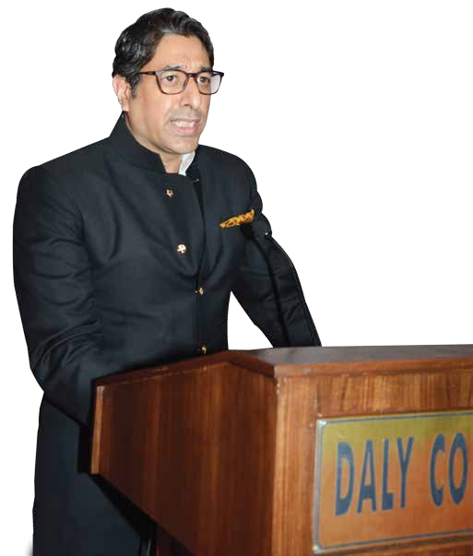

VICWEePlcRomESeIADdEdNreTss'S
Honourable Chief Guest, Sumitra Mahajan ji,
members of the governing board, Principal, Neeraj Bedhotiya, sir, distinguished guests, parents, staff, dear students and the reunion batch of '93.
On behalf of Daly College, a very warm welcome to everybody on its 148th Annual Prize Giving function. Friends, it is indeed a moment of immense pleasure and pride to have amongst us our chief guest, Shri Sumitra Mahajan ji, also affectionately known as 'Tai'.A lady of sterling qualities, she has remained a member of the parliament for a record eight times and has been entrusted with several other important portfolios, before she assumed the momentous responsibility of the speaker of the Lok Sabha.
Thank you, ma'am, once again, on behalf of all of us present here and the school, we extend a warm welcome.It is indeed heartening to see the large turnaround in the school.
Before we start the function, I would like to take a moment to thank all my colleagues on the board , the governing body and the Principal,and their efforts and their initiatives as a result of which we can boast of a greener campus, new infrastructure for sports and greater student participation in various co-curricular activities in addition to academic growth. Encouragement of team games has produced rich evidence in the IPSC results as well and the special gold credit goes to the Principal for this, for encouraging team sports in the school.
Friends, the school remains committed to producing well-rounded individuals who can overcome the challenges of the 21st century.
Last but not least, I am proud to inform you that the school now has a reserve fund of almost 50 crores.Thanks to the strict ﬁnancial discipline instilled by the board and the Principal.This will be utilized to provide newer and better facilities for students in the years to come.
A warm welcome to all of you once again. Thank you.
Jai Hind
Mr. Devraj Singh Bad

